TCP/IP Attack Lab

Lab Environment
We set up the network as mentionned but we keep ip as we want it should be something like this:
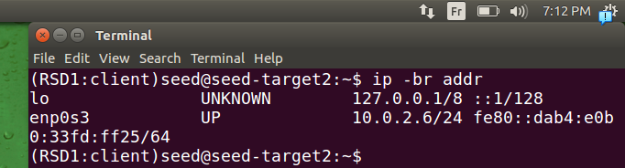
.for client
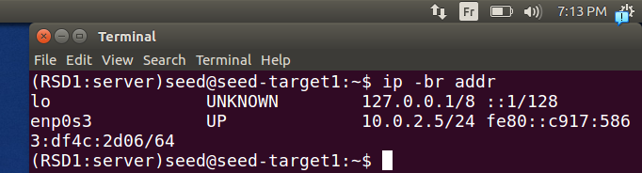
.for server
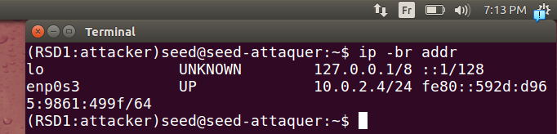
.for attacker
I don’t think we will use it but just to see it, this is netwag
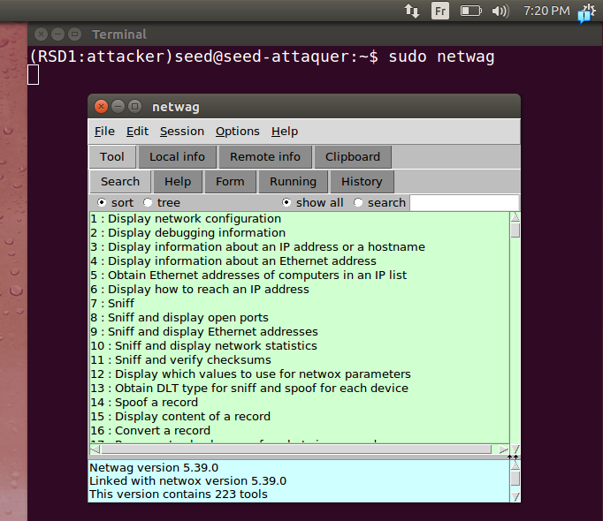
.

Lab Tasks

Task 1: SYN Flooding Attack
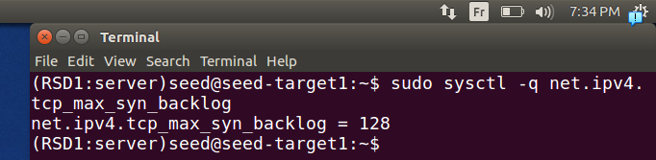
This means that the server can hold 128 half connections on SYN backlog (queue) before it starts refusing next ones or using syncookies. (it depends on configuration by default it’s using syn cookies)
.
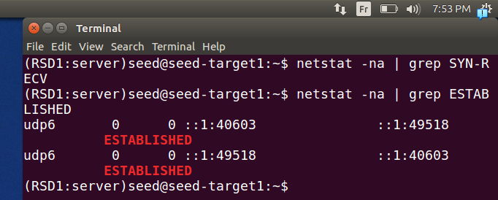
.
here we can see no half openned connection
and 2 connection complete for udp in ipv6 and we can see it’s between our interface loop back of ipv6 from the port to the a port,

.case syn cookies are working(telnet) using netwox tool:
.
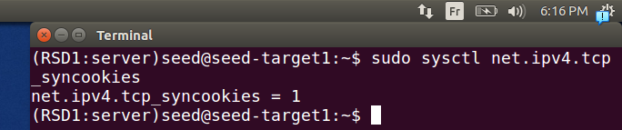
.here default case for a machine is to have the syncookies working on . Here the machine server we will try to innonde it .
.
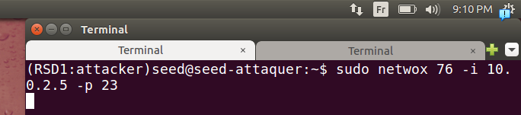
.here we use netwox tool as mentionned previously, note that -i is for destination and -p port destination also.

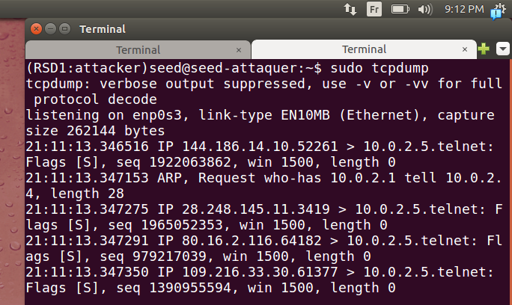
.we can see that it’s working when we open we lunch our tcpdump command (ip address of source is random for each packet and port src also random), flag is set to S for syn.
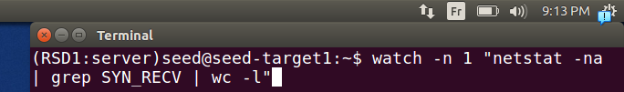
Here
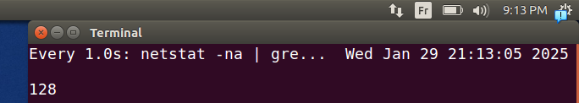
.here we can see that we have got 128 It’s satured = max.
note that this the value that make the syn cookies start working it’s a mecanisme that starts when the syn flooding is detected.
.
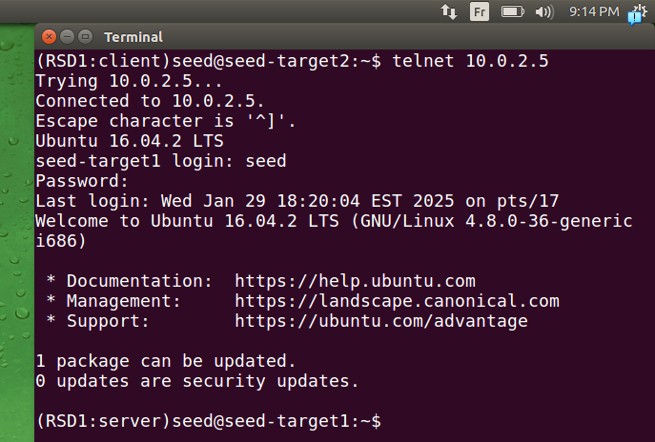
.here we could connect because syn cookies is activated it worked fine and no latency noticed.
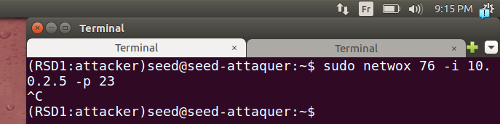
.if we stop our tool from attacker machine.

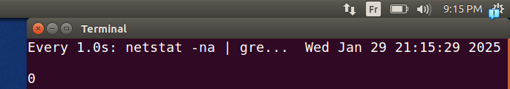
.we can see that it returned to 0 number of half connections

.case syn cookies aren’t working(telnet) using netwox tool:
.now when the victim isn’t using syn cookies (we will be disapling it by ourself par defualt it’s activated)
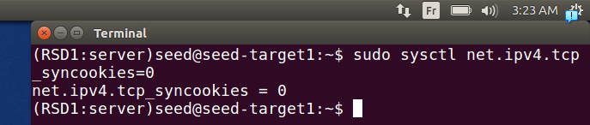
.in machien server we disable the syn cookies
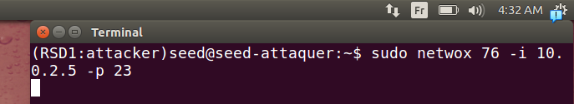
.here we lunch attack from the attaker machine
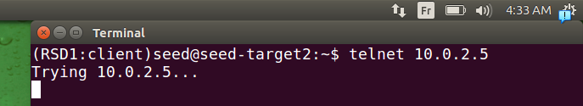
.here we try to connect it will take time so let’s talk about other things until it’s finnished.
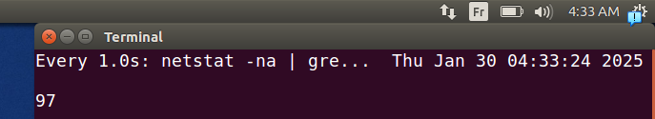
.this is why we couldn’t connect because the syn cookies is disactived so the machine server is discarding the packets until those old ones are finished
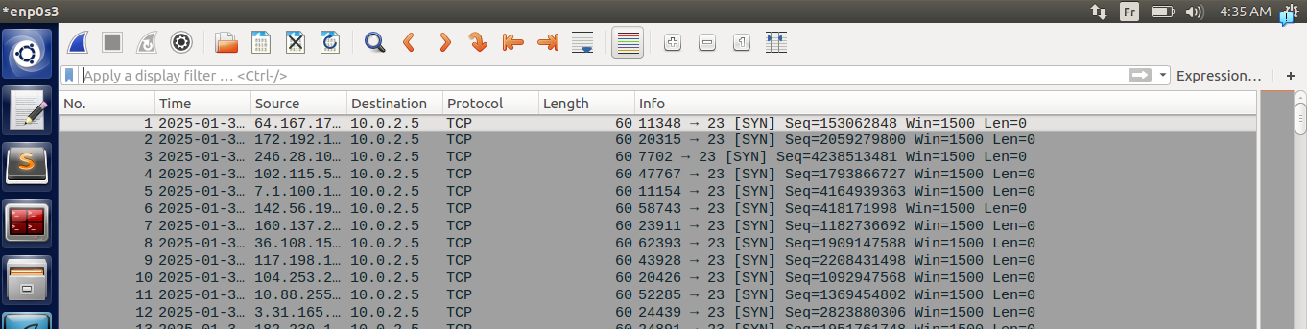
.here we can see it also in wireshark it’s working correctly he’s overwhelmed with packets we can’t even see any syn+ack because he’s waiting for ack from the first machines
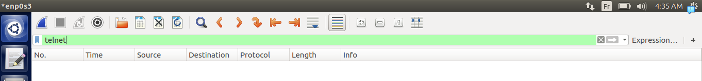
.here if we use the filter telnet we can see that it didn’t connect.
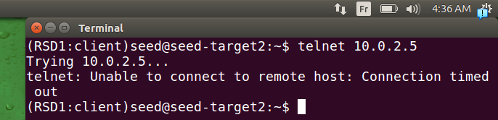
.we can see it here, unable to connect because client paquets (syn) are being discarded.

.case syn cookies aren’t working(ssh) using netwox tool:
.we will just try it also with ssh and see if it works
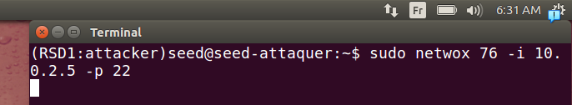
.here we luch the command to attack.
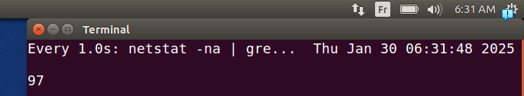
.same as last time
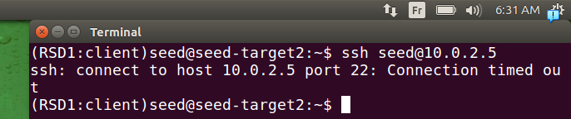
.same goes for ssh it didn’t connect.
Why 97 in the second and 128 in the first?
Because in the first the syn cookies works when he reches threshold high = 128 and then start to use it (so he detects it after)
on the second one he’s not permitting it to reaches 128 and begin to discard paquets.

.case syn cookies aren’t working(telnet) using python:
.
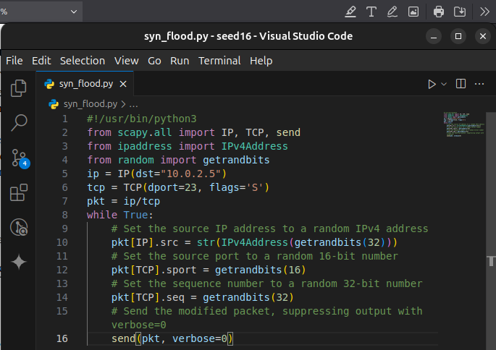
.here we make code python knowing that syn cookies are being disabled, here we made sure to have src port and seq number, ip src random and kepet sending paquets.
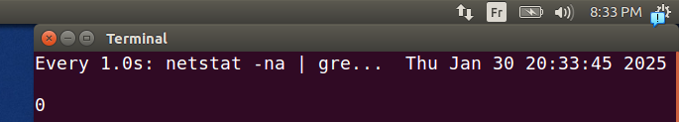
.here we see that before we start our attque no half connection are there.
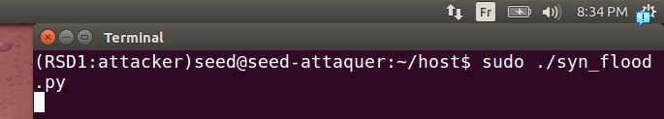
.we lunch our script from attcker machine
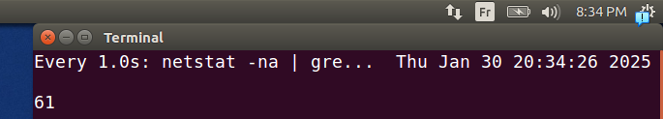
we can see that it started affecting the qeue but not flooding it (it did vary around = 61 < 128 max)
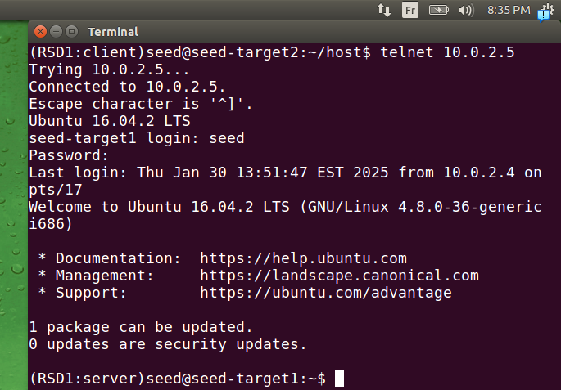
.here we connect through telnet it worked fine .
It didn’t work because python is slow if we tried C it should’ve worked .

Task 2: TCP RST Attacks on telnet and ssh Connections

case telnet using netwox :
.
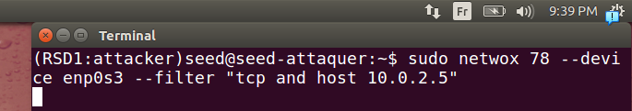
.we lunch tool from attcker machine with parametres enp0s3 our interface, and tcp because telnet based on tcp.(filter)
.
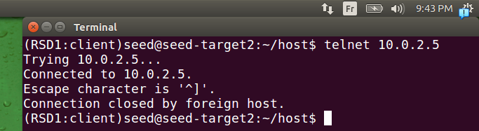
.when tried to attempt it was fast so we couldn’t at all connect.
.
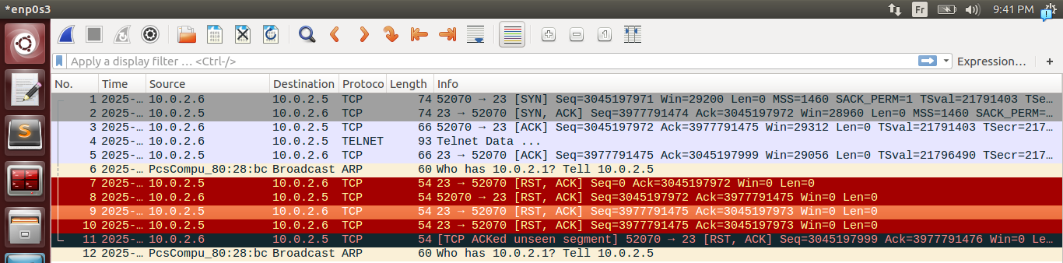
.it worked and for reasearching purpose we opened wireshak
the first 5 paquets are 3 way handshake and after this the start of telnet session one as a response (to do)
for packet 6 and 12 are for network discovery
and the other paquets 7-10 injected attack packets by our tool they are reset packet to focufully stop the connection.(multiple ones to make sure it’s stopped and because seq number keep changing)
And packet 11 TCP ACKed unseen segment 10.0.2.6 expected a response but the connection was focufully stopped.
Note: why do we send on each side RST packet ? It’s because some connections like ssh try to reconnect automatically of connection is sent to just one side and for telnet just one side suffice.
Here we try it on a session that it’s alredy connected.
.
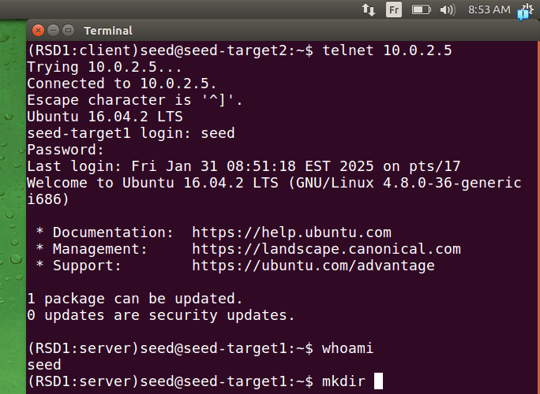
.here we are connected we are writing commands
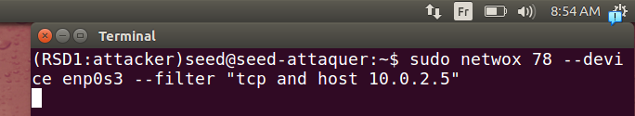
.here we lunch our script from the attacker machine
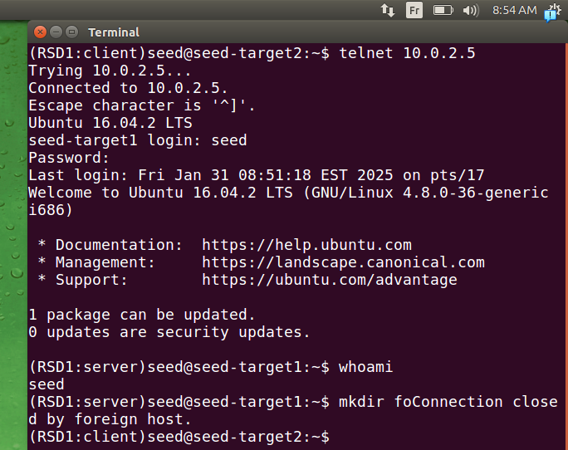
.then it’s stopped if he enter any carracter and it’s stopped.

case ssh using netwox :
We start with the case he’s not connected yet.
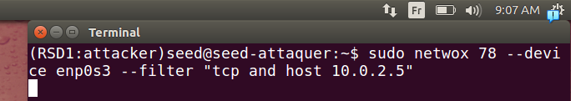
.we lunch our script from attacker machine
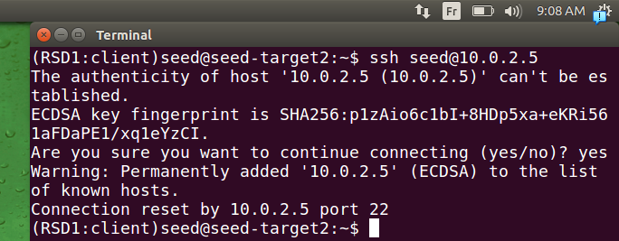
.he couldn’t connect as we see here unlike telnet it’s given to you even ip and port number
another case should be when they are already connected
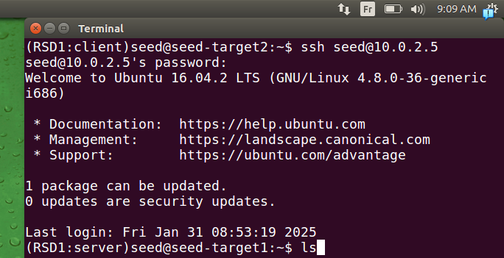
.we are typing somme commands
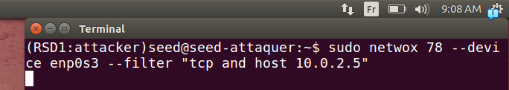
.we lunch sript from machine ackert
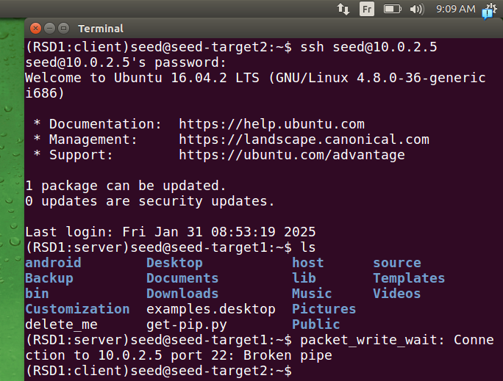
here when we were tying to wrote on client side to server side and after lunching a cammmend we got it stoppend by attaquer(RST packet)

case telnet using python :
.
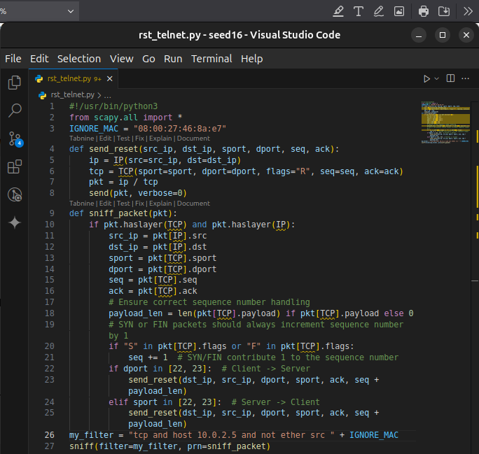
.in this code we define two function one for sending RST packets, and one for treating the packets and giving the 1st function
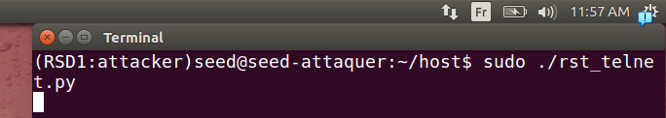
.here we lunch the code from attacker machine
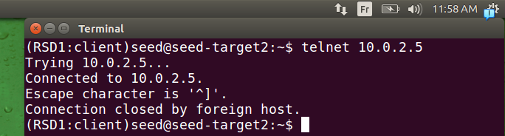
.we just connected and got our connection closed => our script worked succefully
here what if we’re connected already can we stop it? We try this :
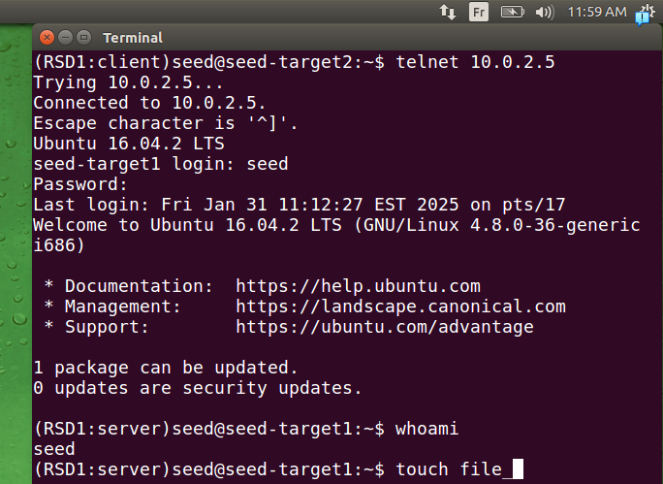
.here we turned off our script, we connected successful and done some commands we didn’t terminate last one to see later if we lunch our script does it stop it
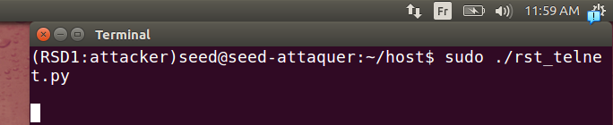
here we lunch our script
.
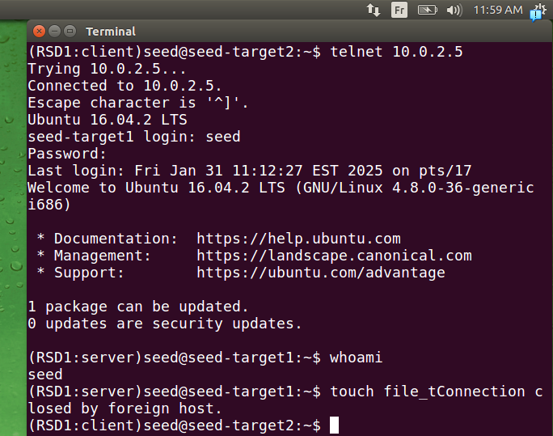
here we tried to write another carracterre our script stopped connection again it worked successfuly

case ssh using python :
.like last we try it when connected and when disconnected:
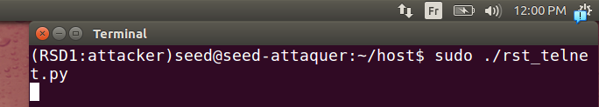
.we lunch our script
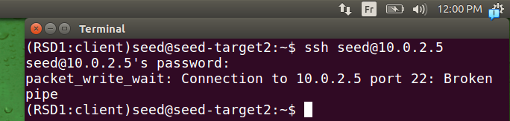
.here he tries to connect and it stoped so our scritp worked correctly again
we try with connection already done .
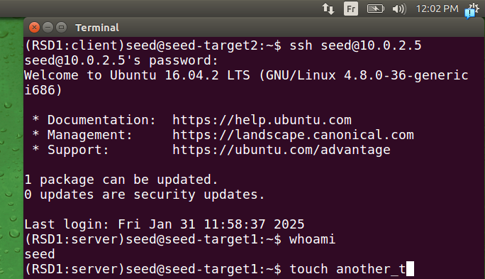
.here we do the same as last time we try some commands
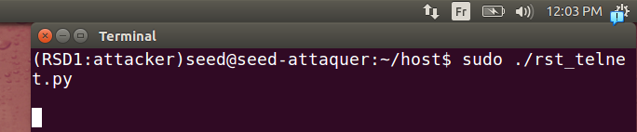
we lunch our scriot
.
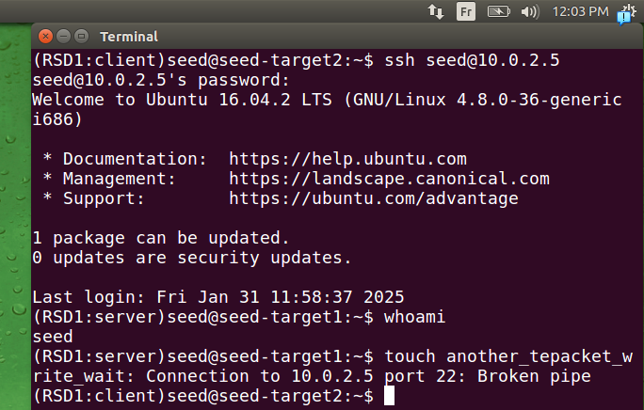
.next caracterre is his last.

Task 3: TCP RST Attacks on Video Streaming Applications

Using Netwox:
.
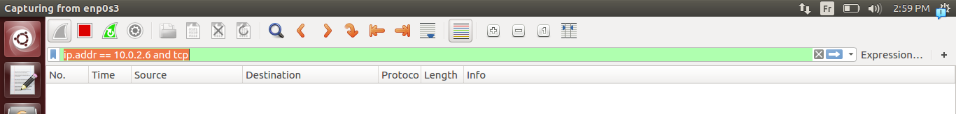
.in wireshark to see monitor the attack we chose ip address of victim and tcp as protocol used
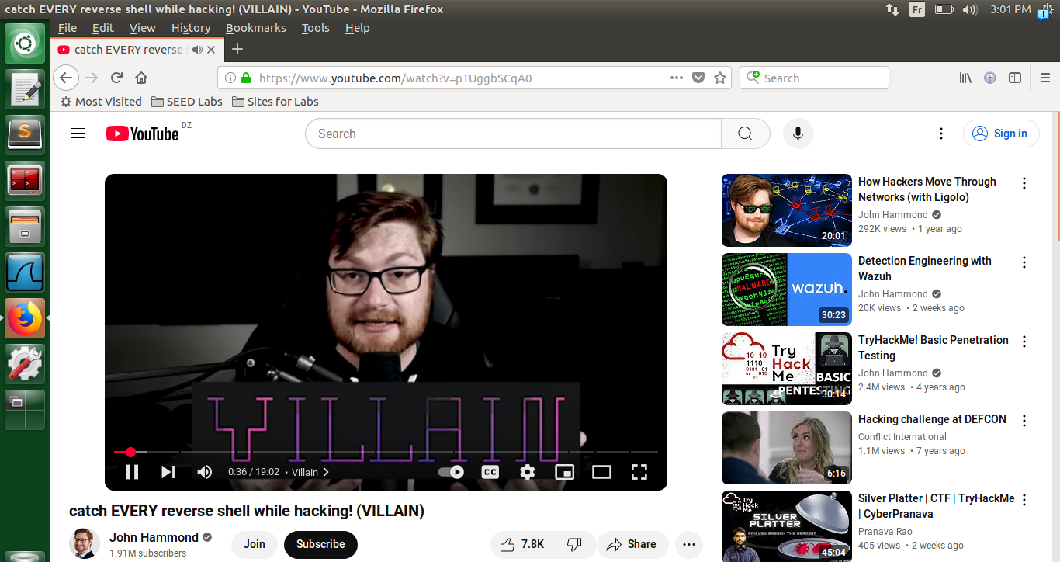
.here we lunch a video and for fiability we can see that we advanced for video teclechargement advance means connection is good and it works good.
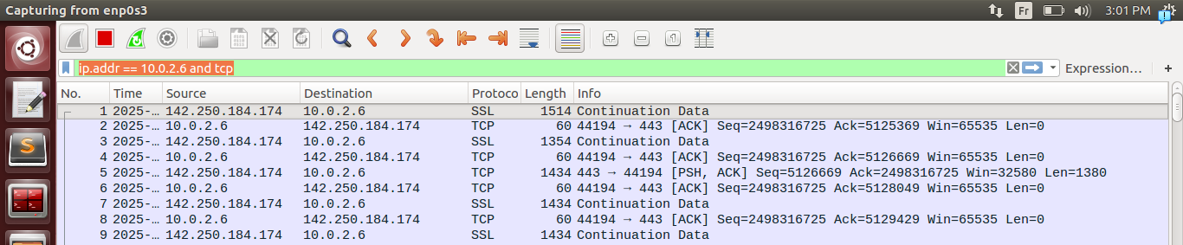
.we can see it in wireshark it works good.
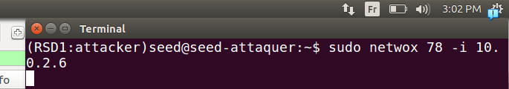
.he we lunch the attack on the client machine
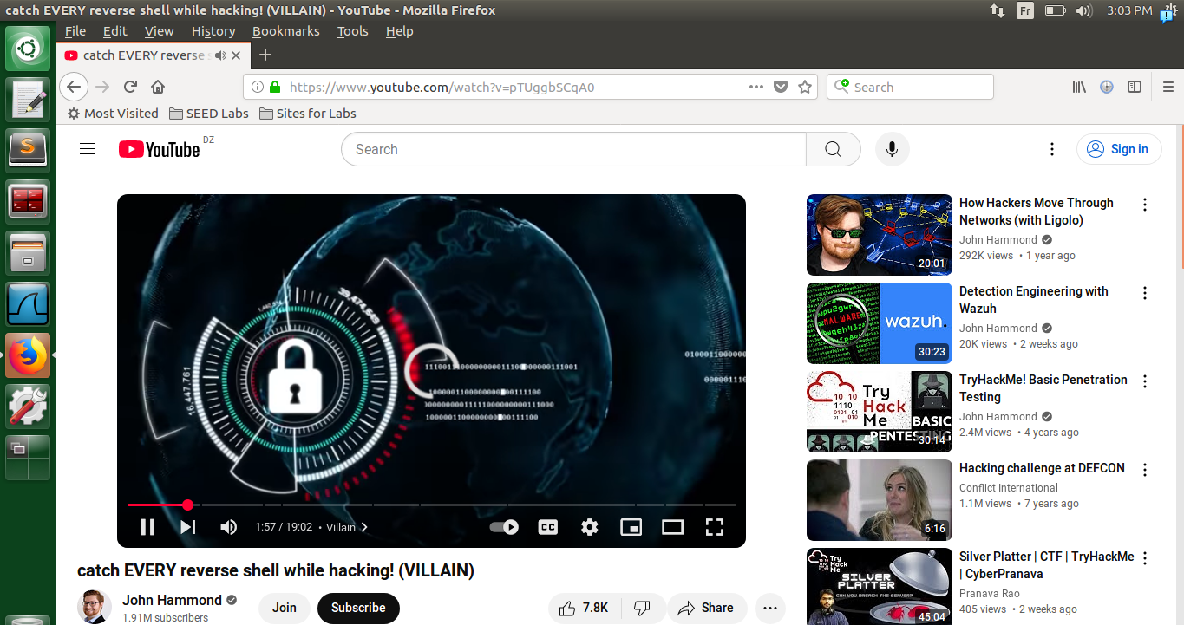
.here we see the youtube video stopped and no forward download of the video can be seen.
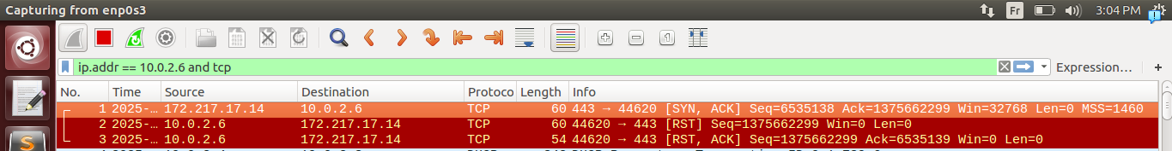
.here we can see reset packets sent to stop the connection
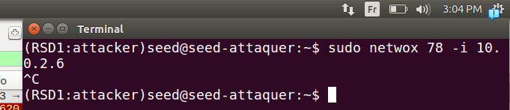
.when we stop the script
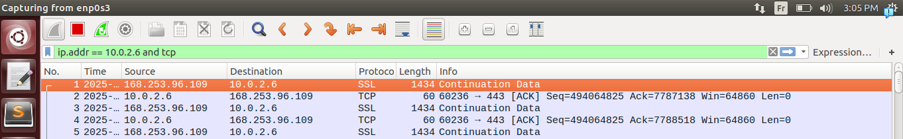
.it start to work again
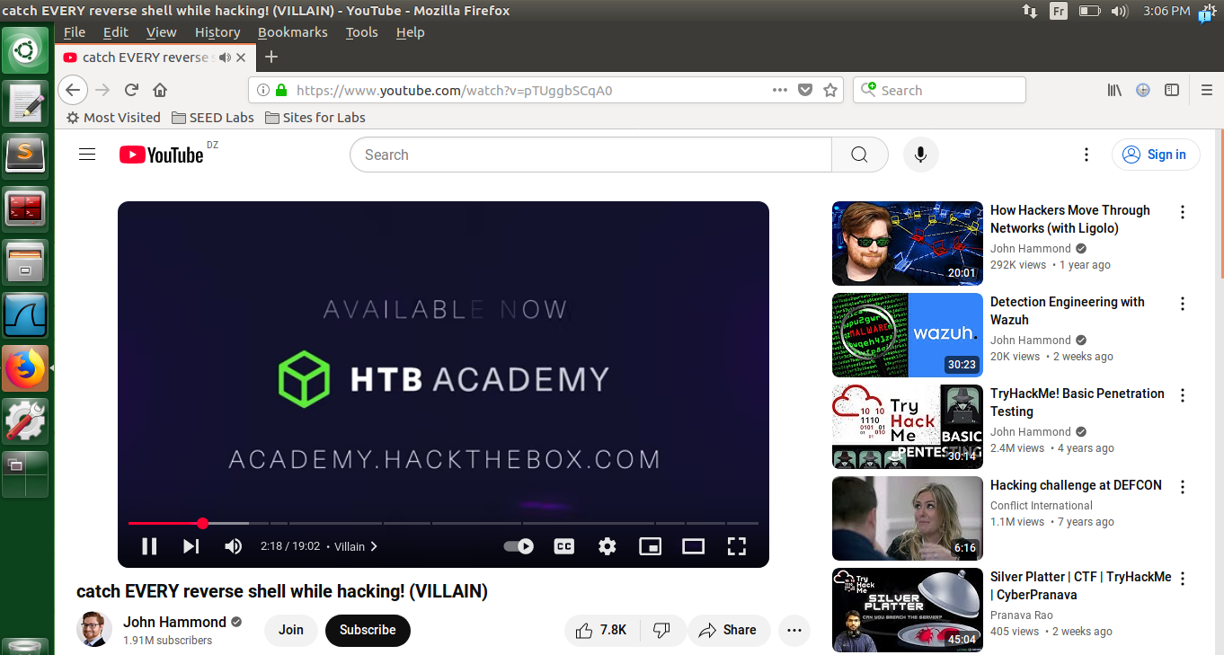
.the video started again to work and advanced again

Task 4: TCP Session Hijacking:
.

Using Netwox.
.
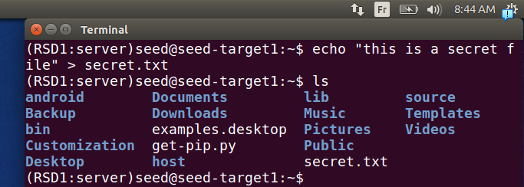
.here we create a secret file it will contain like a password or something we will try to get it’s content
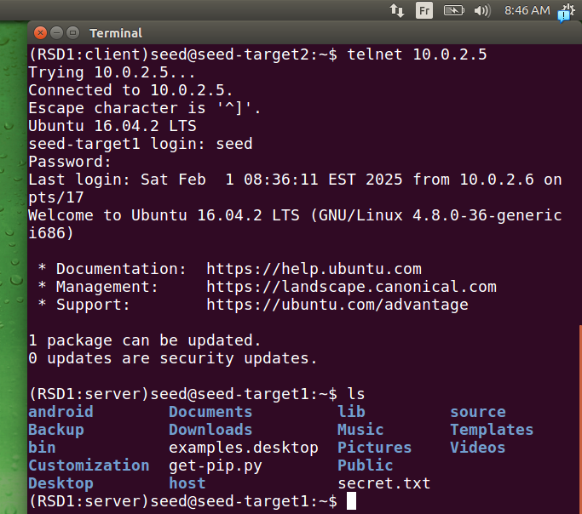
.here we connect via telnet to server machine
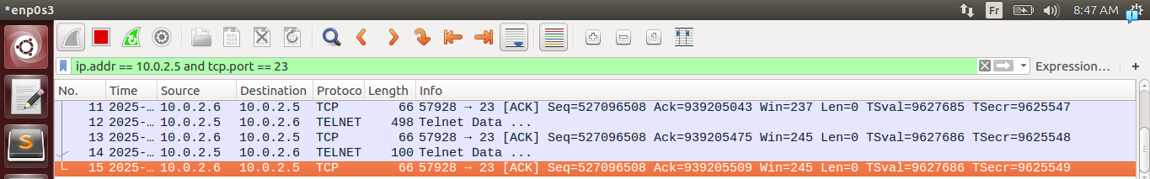
.here we captured last packet to get seq, ack, src port needed for our attack
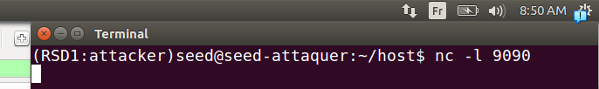
.here we lunch a listten session using netcat, here we will receive the content of secret file.

.
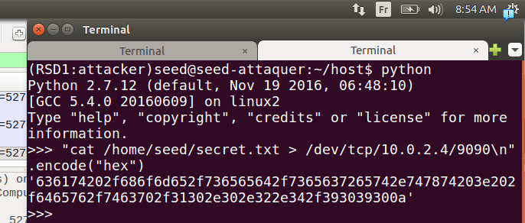
.here as the tool needs the data to be in hex format we use as mentionned in lab python interpretter command line to code our command to hex, note that we put ‘\n’ to separate it from other commands, our command take the output of the cat that shows content of secret.txt file created by us and send it to socket that’s waiting using netcat to our attacker machine on port 9090
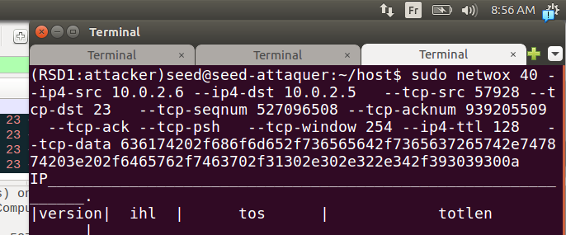
.here we lunch our attack using the tool note that we put flags (ack and psh) because we remarqued that commands sent are contain them always, and we put seq, ack, src port as last paquet.
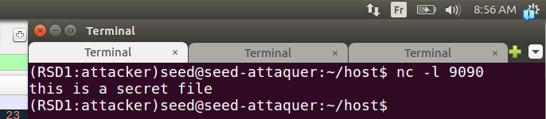
.here in the listen side of the attacker we can see the result clearly.
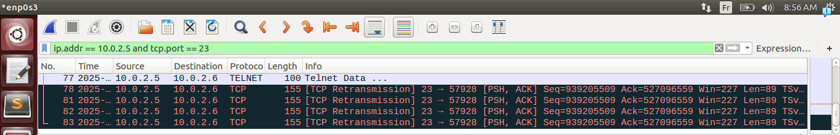
..here we can see our message sent, and it start to send TCP retransmission because in normal
client(10.0.2.6) => server(10.0.2.5) (send the key)
server(10.0.2.5) => client (10.0.2.6) (send the key back)
client(10.0.2.6) => server(10.0.2.5) (here the acknowledgement from the client) this one is missing!!! this make it the server begin sending TCP retransmission to client, and the client keep discarding the messages because bad ack received.
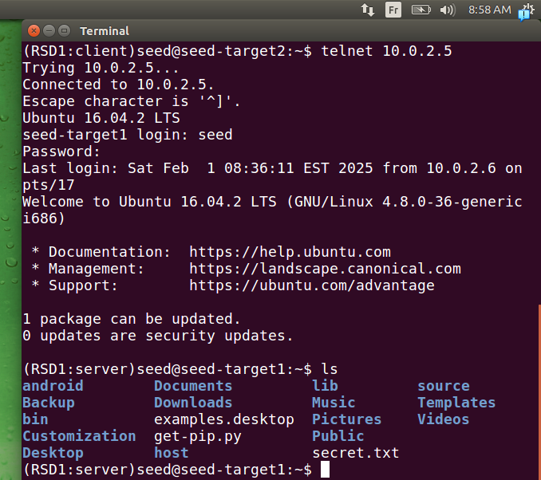
.here we can see in client side that we’re being jaled we can’t see anything (jailed not really because like we told in last Tps the content writing and seen when we key stroke is the respond of the server machine like here we’re writing ls and pressing enter but nothing is showing it’s because we’re not getting response waiting for)
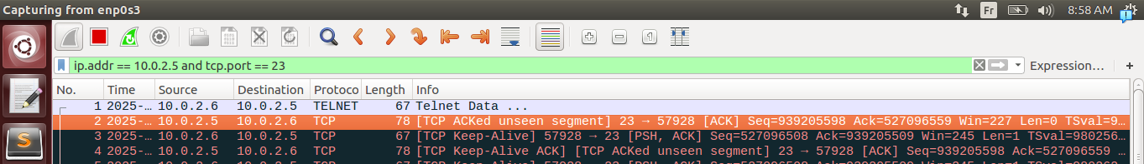
.here we can see it clearly we are sending out data, but because server expected something else he’s droping paquets( because false seq, ack) and asking again about the ack we mentionned earlier.

Using Scapy.
.
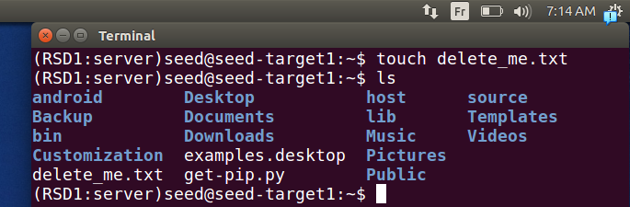
.here we create a file to delete later
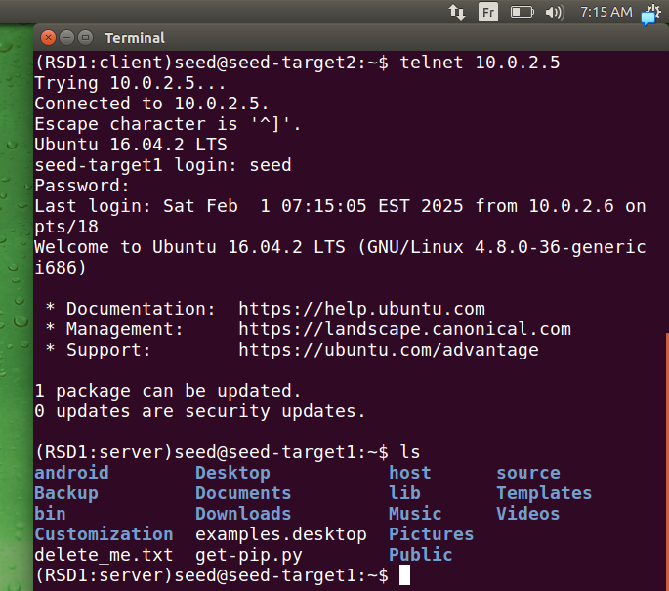
.here we connect to machine server and show what is in home directory and ther’s the file we deleted
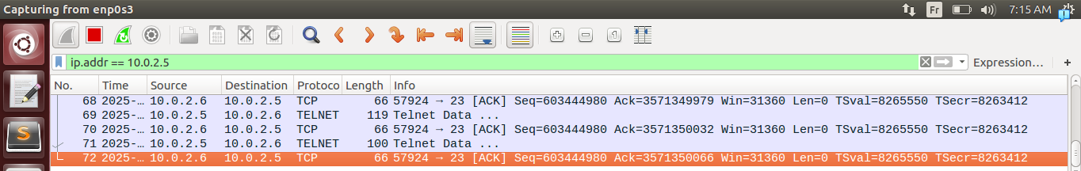
.here we intercept last packet to take the seq, ack, port src numbers to put them in our script
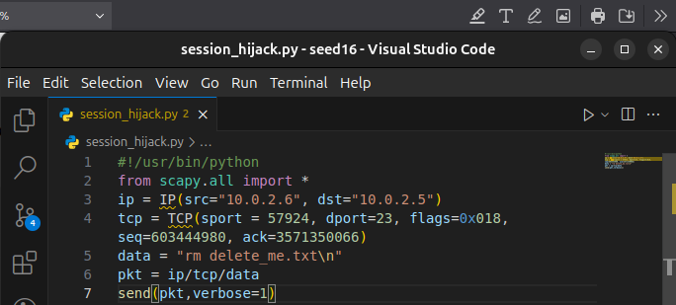
.here we change our script and make the payload of deleting the file we want
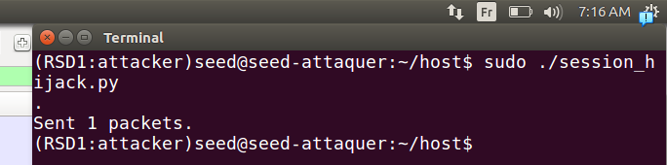
.here we lunch our script from attacker machine.
.
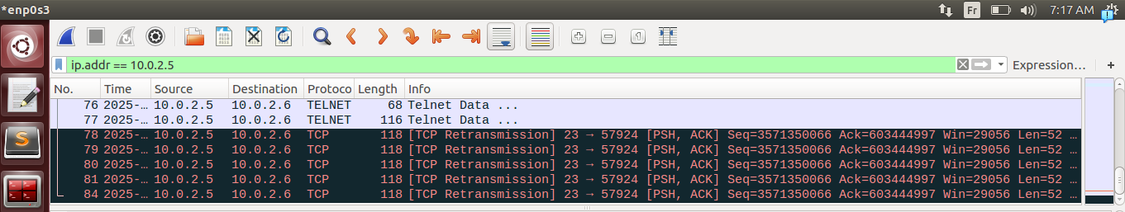
.as mentionned earlier:
here we can see our message sent, and it start to send TCP retransmission because in normal
client(10.0.2.6) => server(10.0.2.5) (send the key)
server(10.0.2.5) => client (10.0.2.6) (send the key back)
client(10.0.2.6) => server(10.0.2.5) (here the acknowledgement from the client) this one is missing!!! this make it the server begin sending TCP retransmission to client, and the client keep discarding the messages because bad ack received.
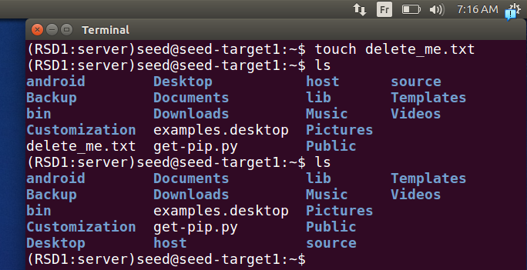
.and in server if we see the file did delete successfully
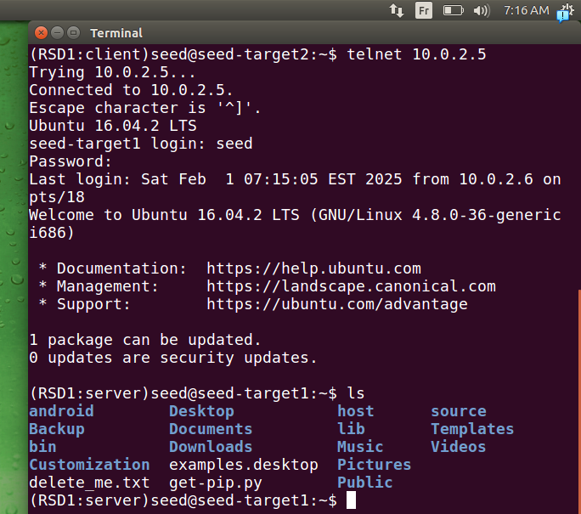
.here in client if we try key strocking in client side it doesn’t work because:

.
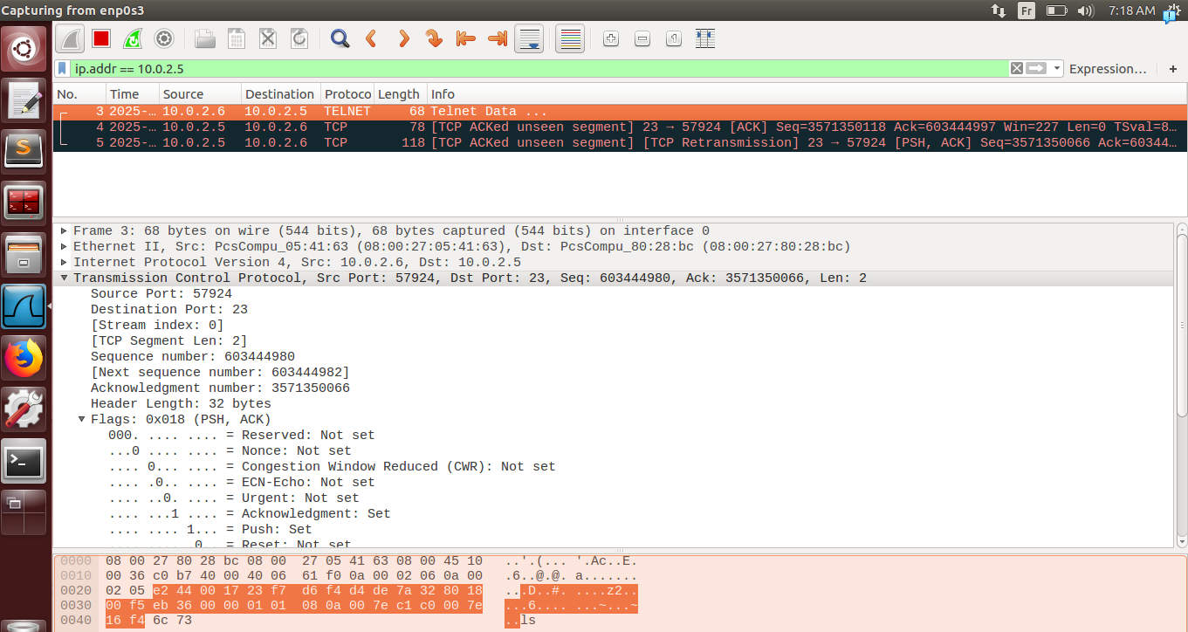
here we see legimate command sent by the client victim, the server discarded it because not correct Ack and seq numbers
then the server sends again TCP retransmission asking about the repsonse that it didn’t got
we got connection not stable between the two client and server.
After time we got connection closed.
A Note every command injected can be seen in history of server as it excuted by him
and note also that we’re capturing a specific emplacement like if we wanted to excute it automatically it will be more complicated.

Task 5: Creating Reverse Shell using TCP Session Hijacking
.
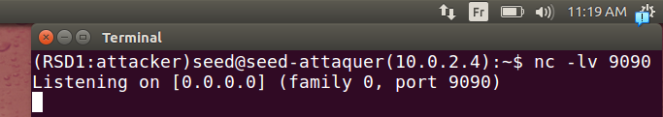
.here we lunched a listner in our machine attacker
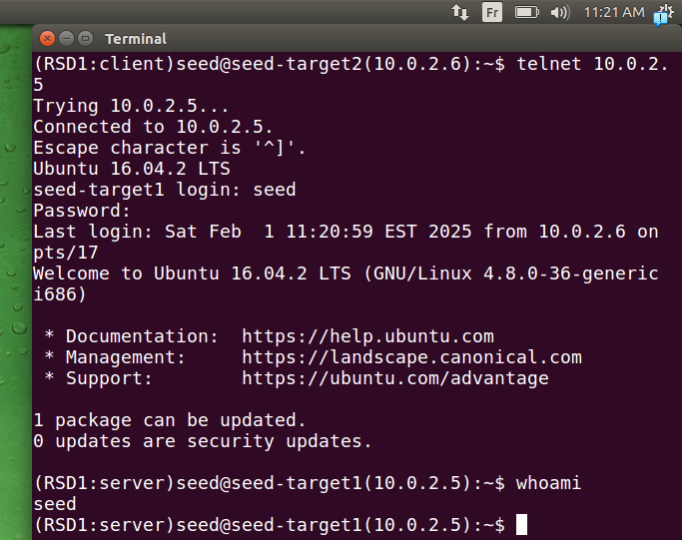
.then we connected via client to the server using telnet
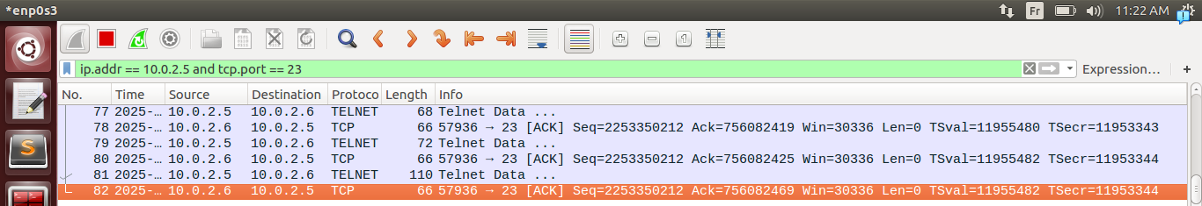
.here we capture last packet to take seq, ack, src port number
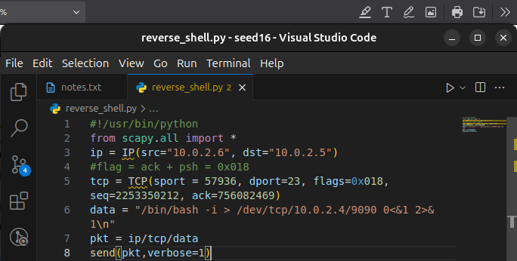
.we change the last code
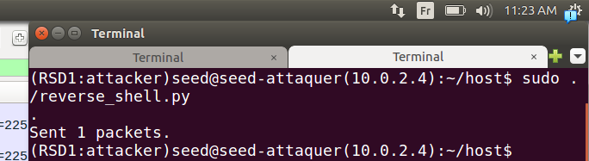
.and here we lunch the script from attacker machine
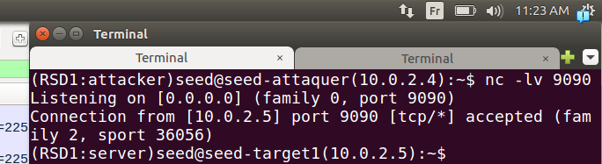
.we see that we got a the connection with session
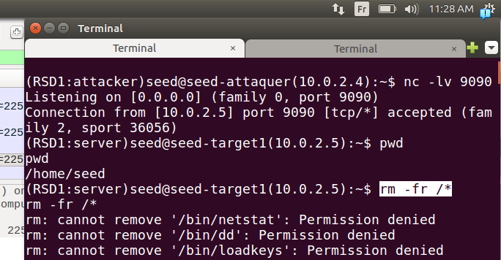
.here we can make commands (!!!!!!!we did a snapshot before doing that command!!!!!)
we had some permission denied if we got him using already a root priveledged command.

.here we got almost everything deleted we still got terminal access only the user priviledge got deleted if we had priveledge even gnome will not live
!!!don’t do it we deleted our host folder that contained the all our scripts(it’s great that we had a backup saved)!!!!
Note also that when we got the reverse shell it got with the previledge and also the emplacement

